|  |  |  |  |  |
| --- | --- | --- | --- | --- |
| |  | | --- | | Leerjaar 2 | VMBO | kader | | | 1.  Afbeeldingsresultaat voor people need people zephaniah________________________________________________________________________________________________________________________________________________________________________________________________________________________________________________  2.  ________________________________________________________________________________________________________________________________________________________________________________________________________________________________________________  3. ________________________________________________________________________________________________________________________________________________________________________________________________________________________________________________ | | |  | | --- | | 1. WHO DO YOU THINK THIS MAN IS?2. WHERE DO YOU THINK HE LIVES? 3. WHAT KIND OF JOB DO YOU THINK HE HAS? |   *- Work in groups of 4*  *- Answer the questions above*  *- Answer in full sentences*  *- 5 minutes to complete the task* |

# Placemat assignment – 15 min.

1. Write down your thoughts on this question in one of the coloured blocks
2. Compare answers to your group members​
3. Write shared values in the central block

# Afbeeldingsresultaat voor placemat opdracht

# Reading activity – 10 min.

1. Read the poem “People need people” individually.
2. Underline the words you don’t understand.

People need people,  
To walk to  
To talk to  
To cry and rely on,

People will always need people.  
To love and to miss  
To hug and to kiss,  
It’s useful to have other people.  
To whom to moan  
If you’re all alone,  
It’s so hard to share  
When no one is there.  
There’s not much to do  
When there’s no one but you.

People will always need people.

To please  
To tease  
To put you at ease,

People will always need people.  
To make life appealing  
And give life some meaning,  
It’s useful to have other people.  
It you need a change  
To whom will you turn.  
If you need a lesson  
From whom will you learn.  
If you need to play  
You’ll know why I say

People will always need people.

As girlfriends  
As boyfriends  
From Bombay  
To Ostend,

People will always need people-  
To have friendly fights with  
And share tasty bites with,  
It’s useful to have other people.  
People live in families  
Gangs, posses and packs,  
Its seems we need company  
Before we relax,  
So stop making enemies  
And let’s face the facts,

People will always need people,  
Yes  
People will always need people.

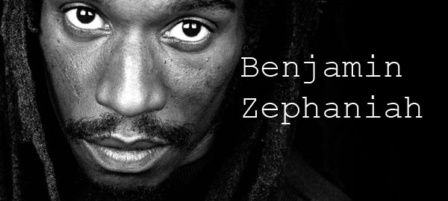

# Reading activity – 10 min.

1. Write down the difficult words you underlined.

____________________________________________________________________________________________________________________________________________________________________________________________________________________________________________________________________________________________________________________________________________________________________________________________________________________________________________________________________________________________________________________________________________________________

1. You are going to watch a video clip about the poem. Try to figure out what the difficult words mean while watching the video clip.

____________________________________________________________________________________________________________________________________________________________________________________________________________________________________________________________________________________________________________________________________________________________________________________________________________________________________________________________________________________________________________________________________________________________

1. Write down 5 words that you think are the most important things people need people for (which are mentioned in the poem by Benjamin Zephaniah).
2. _______________________________________________________________________________________
3. _______________________________________________________________________________________
4. _______________________________________________________________________________________
5. _______________________________________________________________________________________
6. _______________________________________________________________________________________
7. Classroom discussion; about the words that are the most important for you. Make sure you are able to explain why you have chosen these words. You can write some notes here:

____________________________________________________________________________________________________________________________________________________________________________________________________________________________________________________________________________________________________________________________________________________________________________________________________________________________________________________________________________________________________________________________________________________________

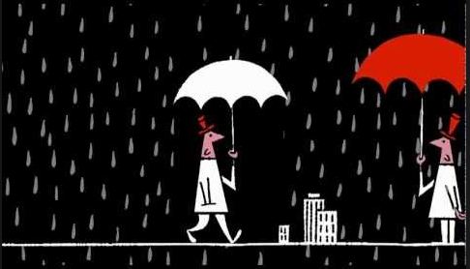

# Post reading activity – 10 min.

Choose one of the two exercises.

You have 10 minutes in class to do a first draft on this assignment and you have to turn it in next lesson. Be creative!

* **Exercise A:** Choose one of the words from the poem that was the most important for you and transfer this into a drawing combined with elements of your own life. You are allowed to draw on paper or use a digital device.
* **Exercise B:** Write your own poem about what you think are the most important elements mentioned in the poem. You can use the words from the top 5 as we have discussed earlier. The poem should consist out of at least 8 sentences.

*Write/draw here.*

# evaluation – next lesson

You will vote for your favourite poem or drawing. Voting will be anonymous.

The poem/drawing that receives the most votes will be posted (anonymously) on our school’s social media accounts.